Installation Guide

# Introduction

First and foremost, we would like to thank you for buying our product. Should you have any issues with it, you can reach out to our support email ([harryharding@iomc.ac.im](mailto:harryharding@iomc.ac.im)). Our typical response time is under 24 hours, and we’re more than happy to assist with any problems you may have.

# Guide

As you have received your solution email, there is a folder attached inside named “Deployment”. This contains all the necessary data you’ll need for your project. In order to initialise the software, you need to:

* Download the folder to your PC.
* 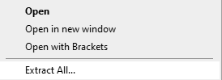Extract the folder so it is no longer a ZIPPED file. This can be done by right-clicking the folder on your PC, and pressing “**Extract All**”.
* Choose where you could like to store the folder.
* Once extracted, open the folder and simply press on your software solution to open it. 